1. Double click on certificate file (.cer) and then click on “Install Certificate”

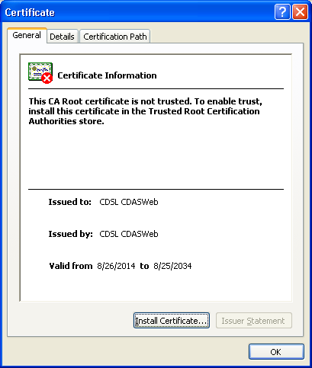

2. Click Next on Certificate Import Wizard

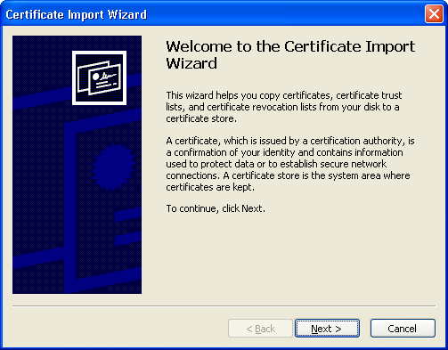

3. Select “Place all certificates in the following store” and then click on browse button.

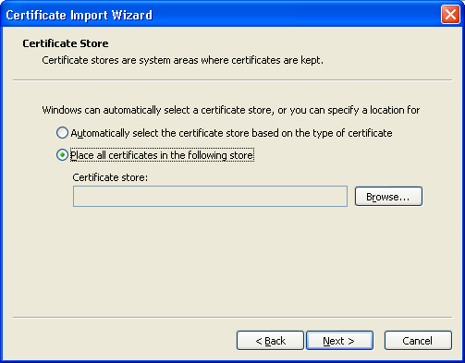

4. Select “Trusted Root Certification Authorities” on select certificate store & click on Ok

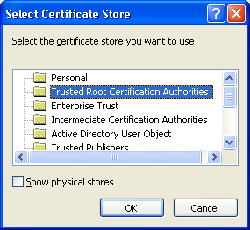

5. Click next once “Trusted Root Certification Authorities” is displayed in Certificate store

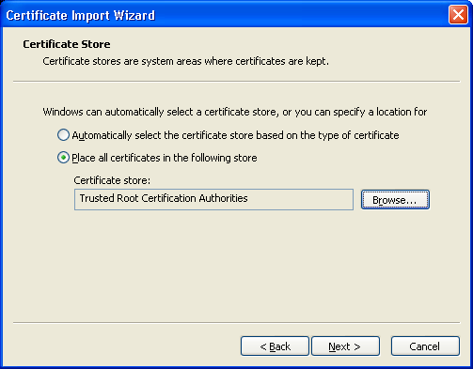

6. Click Finish on Certificate Import Wizard Screen



7. Click Yes on Security Warning Screen.

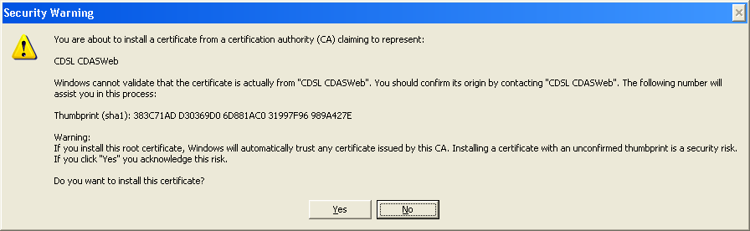

8. On Successful import following message will be displayed.



9. Click on “Install Certificate”

10. Click Next on Certificate Import Wizard

11. Select “Place all certificates in the following store” and then click on browse button.

12. Select “Trusted Publishers” on select certificate store & click on Ok

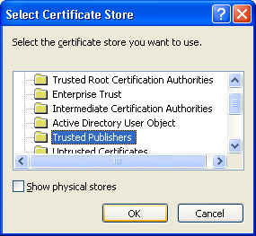

13. Click next once “Trusted Publisher” is displayed in Certificate store

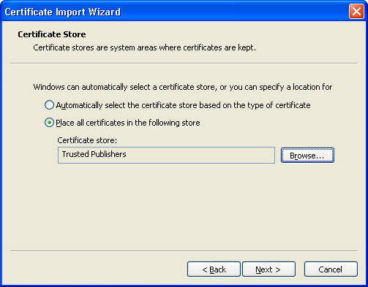

14. Click Finish on Certificate Import Wizard Screen



15. On Successful import following message will be displayed.

